<< LAB 5>>

<<IT24103008>>

<<Jayasingha H.J.M.S.M.>>

1,)

02) 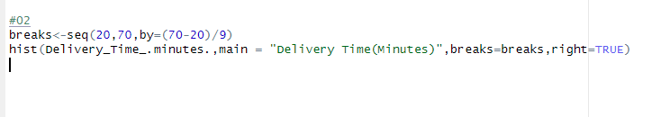

3)

The curve shows a bimodal distribution and appears approximately symmetrical. The data spans between 20 to 70 minutes.

4)

